Assignment No. 1

Step 1: Go to Chrome Web Store Extensions Section. Search MetaMask.
Step 2: Download the METAMASK .Click on the button “Add to Chrome”.

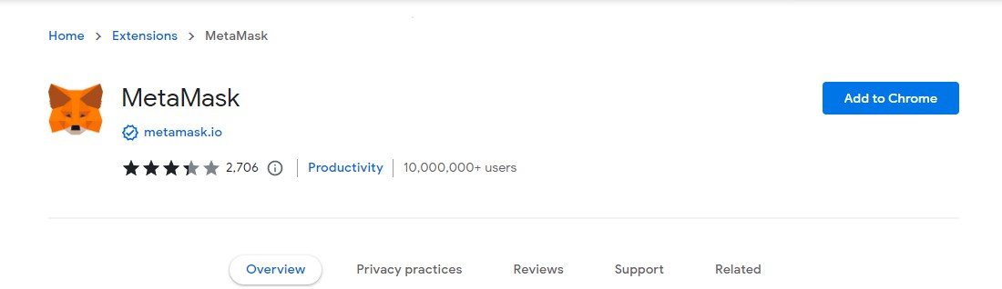


Step 3: MetaMask wallet installation. Click on the MetaMask extension and click on “Get Started”
Step 4: Click on “I Agree.”

